# Setting up InfluxDB Server in Google Cloud Instance

[InfluxDB 2.0 - Complete Guide to Getting Started with InfluxDB 2 - YouTube](https://www.youtube.com/watch?v=-gF-Jsk85bQ)

1. Create appropriate VM instance in Google cloud – Currently using e2-medium.
2. gcloud compute ssh --zone "asia-southeast1-b" "instance-1" --project "x-summit-385305"
3. sudo apt-get update -y
4. sudo apt install docker.io && sudo apt install docker-compose
5. sudo docker ps (verify if docker successfully installed)
6. git clone <https://github.com/devopsjourney1/influxdb-2-dockercompose.git>
   1. Contains config file (.yml)
7. sudo docker-compose up (Rerun this command if server shuts down)
   1. cd to directory containing config file and run command.
8. Configure Firewall Rules: Allow TCP connection to port 8086.
9. Set up Telegraf
10. Access UI via <http://35.240.148.191:8086/>
    1. User: admin, password: changemepls

Figure 1. After running docker-compose up, InfluxDB instance should be running.

Figure 2. Using another terminal, SSH into another console to verify if InfluxDB server running using the sudo docker ps command. Expected output above.

# Configuring Firewall Rules (May need to limit source range to trusted IP)

gcloud compute --project=x-summit-385305 firewall-rules create influxdb-firewall-rule --description="enables access to port:8086" --direction=INGRESS --priority=1000 --network=default --action=ALLOW --rules=tcp:8086 --source-ranges=0.0.0.0/0

# Setting Up Telegraf in InfluxDB Server

1. sudo apt-get install wget
2. wget -q https://repos.influxdata.com/influxdata-archive_compat.key
3. echo '393e8779c89ac8d958f81f942f9ad7fb82a25e133faddaf92e15b16e6ac9ce4c influxdata-archive_compat.key' | sha256sum -c && cat influxdata-archive_compat.key | gpg --dearmor | sudo tee /etc/apt/trusted.gpg.d/influxdata-archive_compat.gpg > /dev/null
4. echo 'deb [signed-by=/etc/apt/trusted.gpg.d/influxdata-archive_compat.gpg] https://repos.influxdata.com/debian stable main' | sudo tee /etc/apt/sources.list.d/influxdata.list
5. sudo apt-get update && sudo apt-get install telegraf

## Creating Example Telegraf System Monitoring

1. Export API Key to Server
2. Start Telegraf in Server

Figure 3. Shows the Telegraf system monitoring for uptime.

# Setting Up InfluxDB Client - Python

1. pip3 install influxdb-client.
2. Obtain token (Not sure if this changes each time).

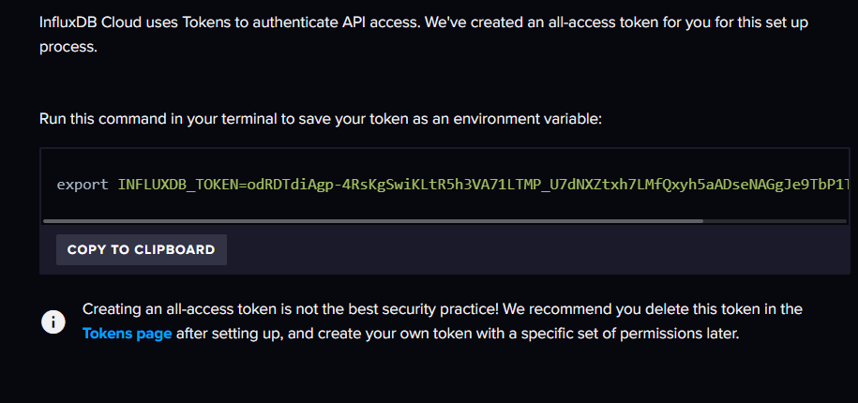

Figure 4.Example of Writing to InfluxDB

1. Visualize Data

